**Spend Project**

***Data Descriptions :-***  
*There are many stores in which a survey was conducted based on students i.e. how much they are spending on different kind of purchases like Video games, Indoor games, Toys, Books, Gadgets etc. In the data set (Student Survey), Store setting is the column that explains the Type of location in which the store is present.*

***Data Cleaning & Modeling :-***Doing Basic Data Clearnings.

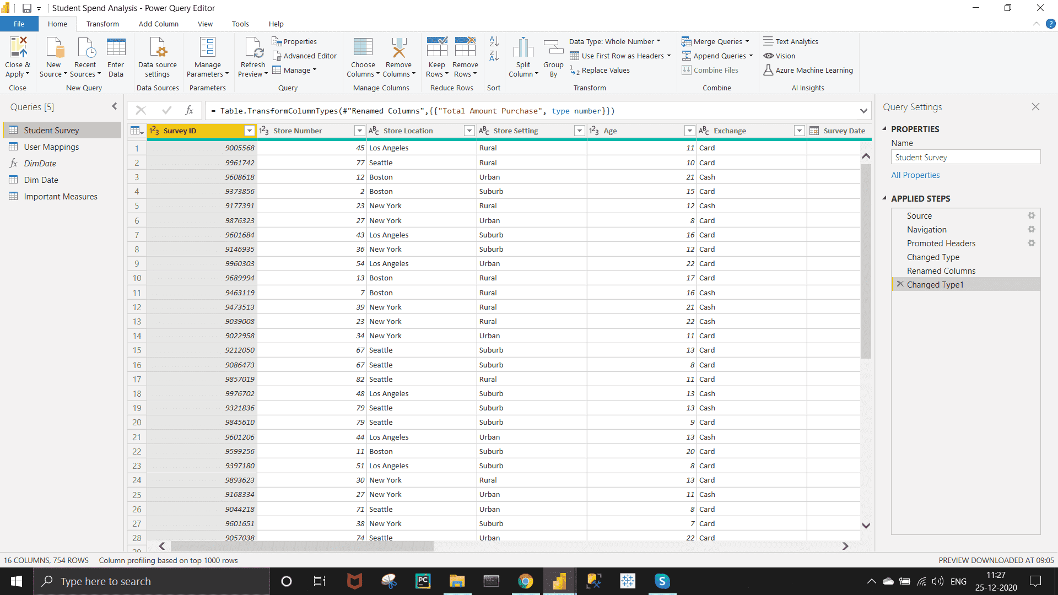

Doing Basic Data Clearnings.

Creating the Date Table by M Query using advanced editor option under Query section of Home. The code is given Below.

**let** fnDateTable = (StartDate **as** date, EndDate **as** date, FYStartMonth **as** number) **as** table =>

**let**

DayCount = Duration.Days(Duration.From(EndDate - StartDate)),

Source = List.Dates(StartDate,DayCount,#duration(1,0,0,0)),

TableFromList = Table.FromList(Source, Splitter.SplitByNothing()),

ChangedType = Table.TransformColumnTypes(TableFromList,{{"Column1", **type** date}}),

RenamedColumns = Table.RenameColumns(ChangedType,{{"Column1", "Date"}}),

InsertYear = Table.AddColumn(RenamedColumns, "Year", each Date.Year([Date]),**type** text),

InsertYearNumber = Table.AddColumn(RenamedColumns, "YearNumber", each Date.Year([Date])),

InsertQuarter = Table.AddColumn(InsertYear, "QuarterOfYear", each Date.QuarterOfYear([Date])),

InsertMonth = Table.AddColumn(InsertQuarter, "MonthOfYear", each Date.Month([Date]), **type** text),

InsertDay = Table.AddColumn(InsertMonth, "DayOfMonth", each Date.Day([Date])),

InsertDayInt = Table.AddColumn(InsertDay, "DateInt", each [Year] * 10000 + [MonthOfYear] * 100 + [DayOfMonth]),

InsertMonthName = Table.AddColumn(InsertDayInt, "MonthName", each Date.ToText([Date], "MMMM"), **type** text),

InsertCalendarMonth = Table.AddColumn(InsertMonthName, "MonthInCalendar", each (**try**(Text.Range([MonthName],0,3)) otherwise [MonthName]) & " " & Number.ToText([Year])),

InsertCalendarQtr = Table.AddColumn(InsertCalendarMonth, "QuarterInCalendar", each "Q" & Number.ToText([QuarterOfYear]) & " " & Number.ToText([Year])),

InsertDayWeek = Table.AddColumn(InsertCalendarQtr, "DayInWeek", each Date.DayOfWeek([Date])),

InsertDayName = Table.AddColumn(InsertDayWeek, "DayOfWeekName", each Date.ToText([Date], "dddd"), **type** text),

InsertWeekEnding = Table.AddColumn(InsertDayName, "WeekEnding", each Date.EndOfWeek([Date]), **type** date),

InsertWeekNumber= Table.AddColumn(InsertWeekEnding, "Week Number", each Date.WeekOfYear([Date])),

InsertMonthnYear = Table.AddColumn(InsertWeekNumber,"MonthnYear", each [Year] * 10000 + [MonthOfYear] * 100),

InsertQuarternYear = Table.AddColumn(InsertMonthnYear,"QuarternYear", each [Year] * 10000 + [QuarterOfYear] * 100),

ChangedType1 = Table.TransformColumnTypes(InsertQuarternYear,{{"QuarternYear", Int64.Type},{"Week Number", Int64.Type},{"Year", **type** text},{"MonthnYear", Int64.Type}, {"DateInt", Int64.Type}, {"DayOfMonth", Int64.Type}, {"MonthOfYear", Int64.Type}, {"QuarterOfYear", Int64.Type}, {"MonthInCalendar", **type** text}, {"QuarterInCalendar", **type** text}, {"DayInWeek", Int64.Type}}),

InsertShortYear = Table.AddColumn(ChangedType1, "ShortYear", each Text.End(Text.From([Year]), 2), **type** text),

AddFY = Table.AddColumn(InsertShortYear, "FY", each "FY"&(**if** [MonthOfYear]>=FYStartMonth then Text.From(Number.From([ShortYear])+1) **else** [ShortYear]))

**in**

AddFY

**in**

fnDateTable

Then Click on " Close & Apply " under home section to apply your Steps..

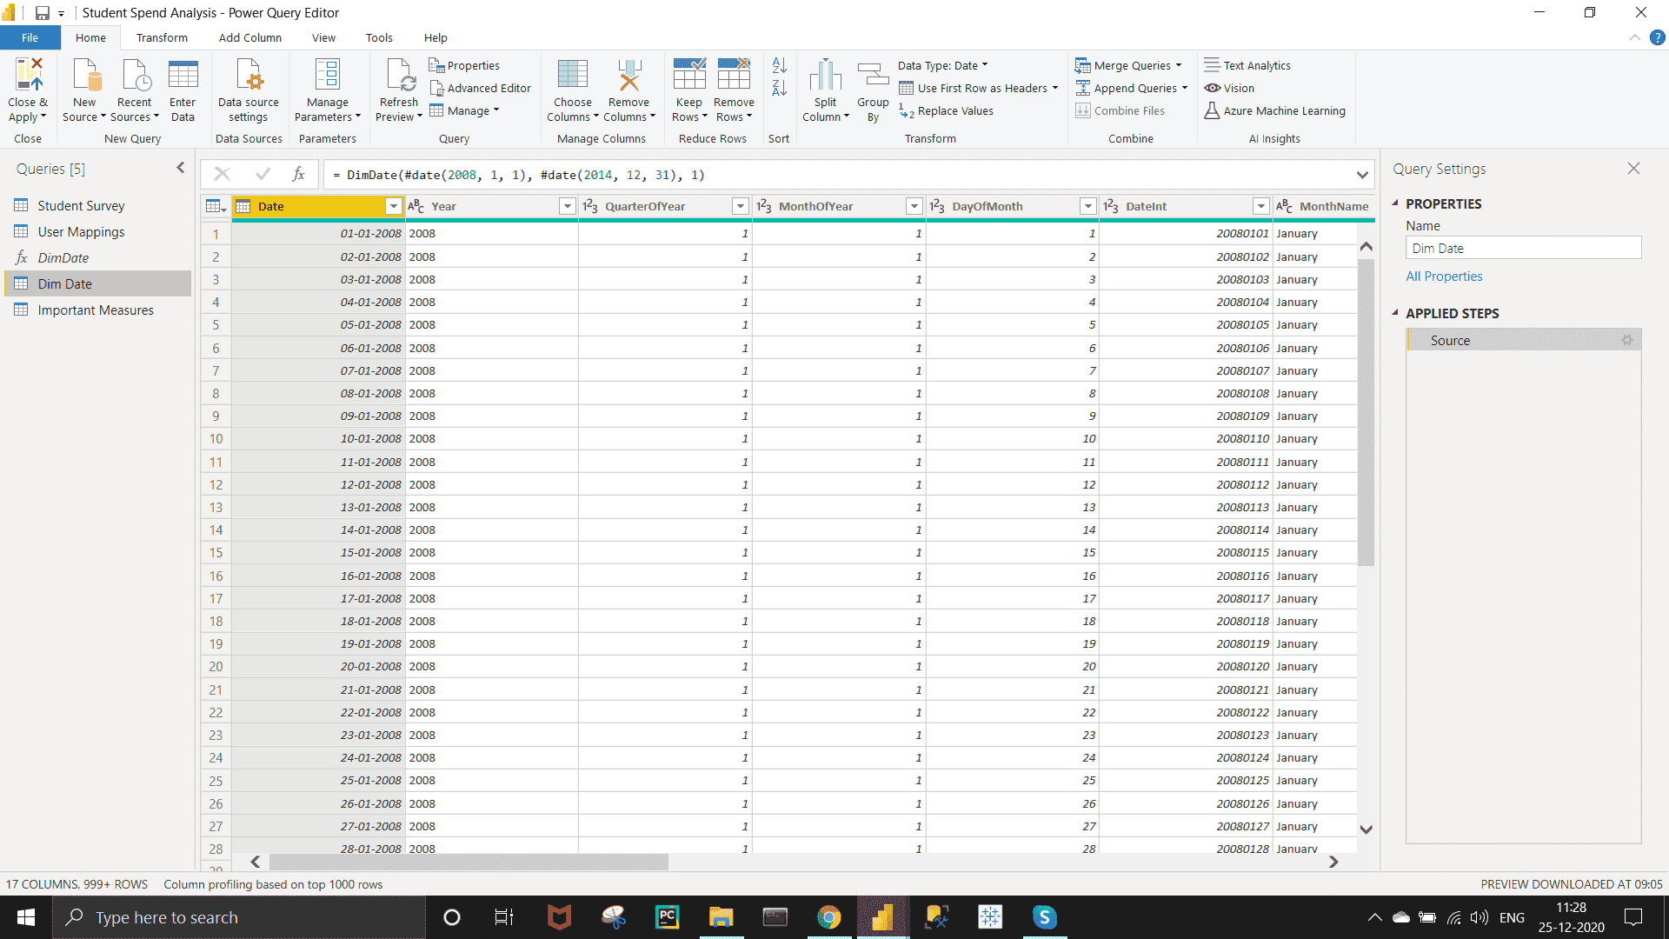

In the Model View, connecting Survey Location with Store Setting  and Date with Survey Date as shown the below snapshot.

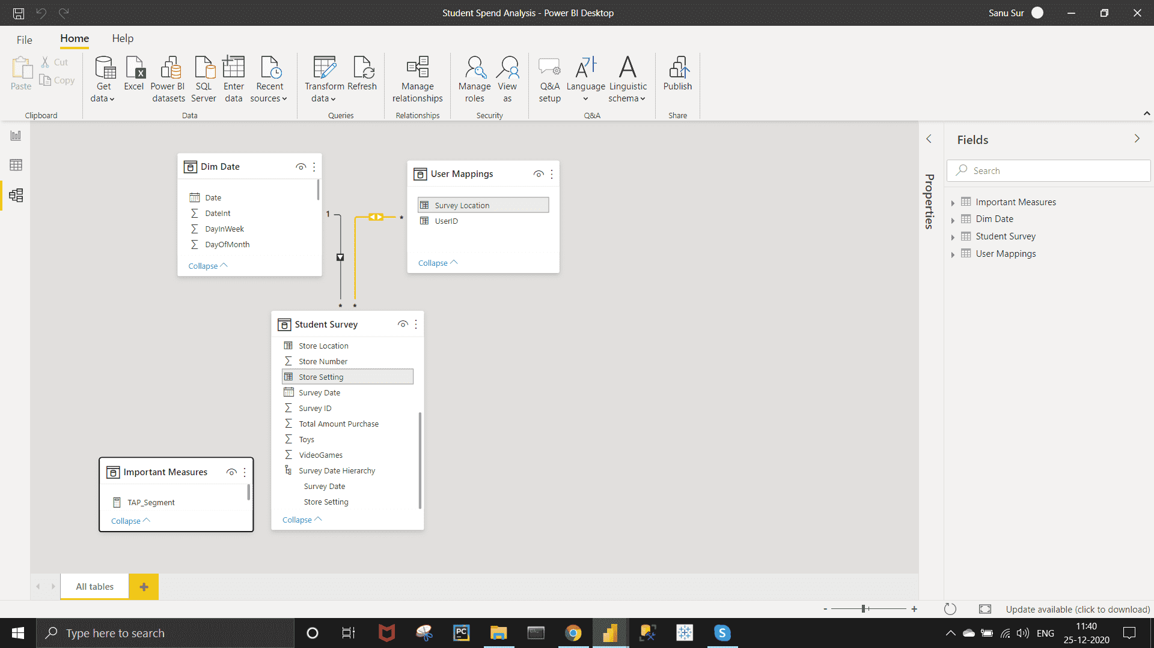

***Report and Dashboarding :-***

*Requirement 1:- Tabular Visualization - Format the total amount of purchase (TAP) based on ‘Store location’ and ‘Store setting’: -  
If 0<TAP<35000, then records should be in red color  
If 35000<=TAP<60000, then records should be in yellow color  
If TAP>=60000, then records should be in Blue color.*

*Approach :-*

Creating Measures

**Total** TAP = SUMX('Student Survey', 'Student Survey'[Total Amount Purchase])

TAP_Segment = SWITCH( TRUE(),  [Total TAP]<35000,"Low Sales",  [Total TAP]<60000, "Moderate Sales","High Sales")

Create a Table or Matrix visual  >> Under the Visualization Pen ,go to field >> Bring Store Settings and Store Location under the row section and Total TAP under the Value section   and click on the dropdown of it >>  Conditional formatting >>  Background color.

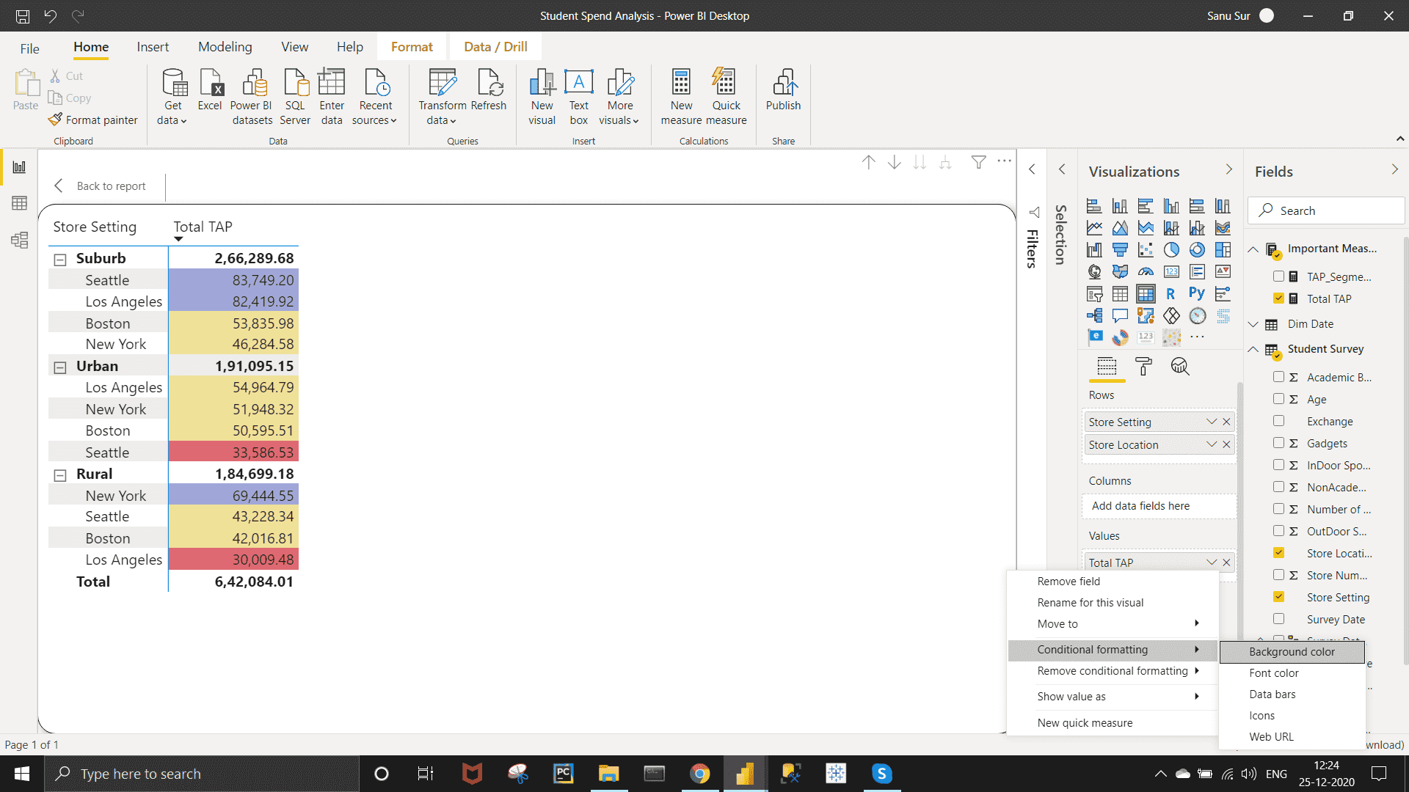

Select the following field and give the condition as shown on the below image.

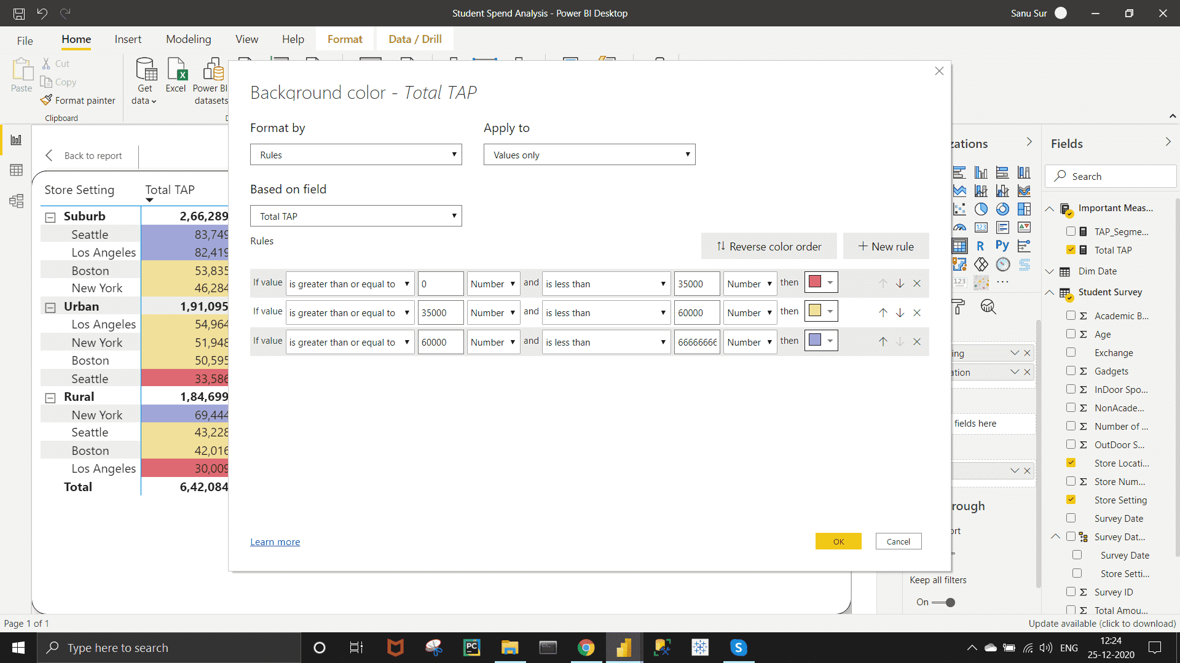

*Requirement 2 :-  
Create Matrix Visualization to show the amount spent on Outdoor sports across different ages and ‘Store setting’. Do the color formatting for the amount spent in total outdoor sports.*

*Approach* :-

Doing it with same steps ,which I already shown in the previous requirement.

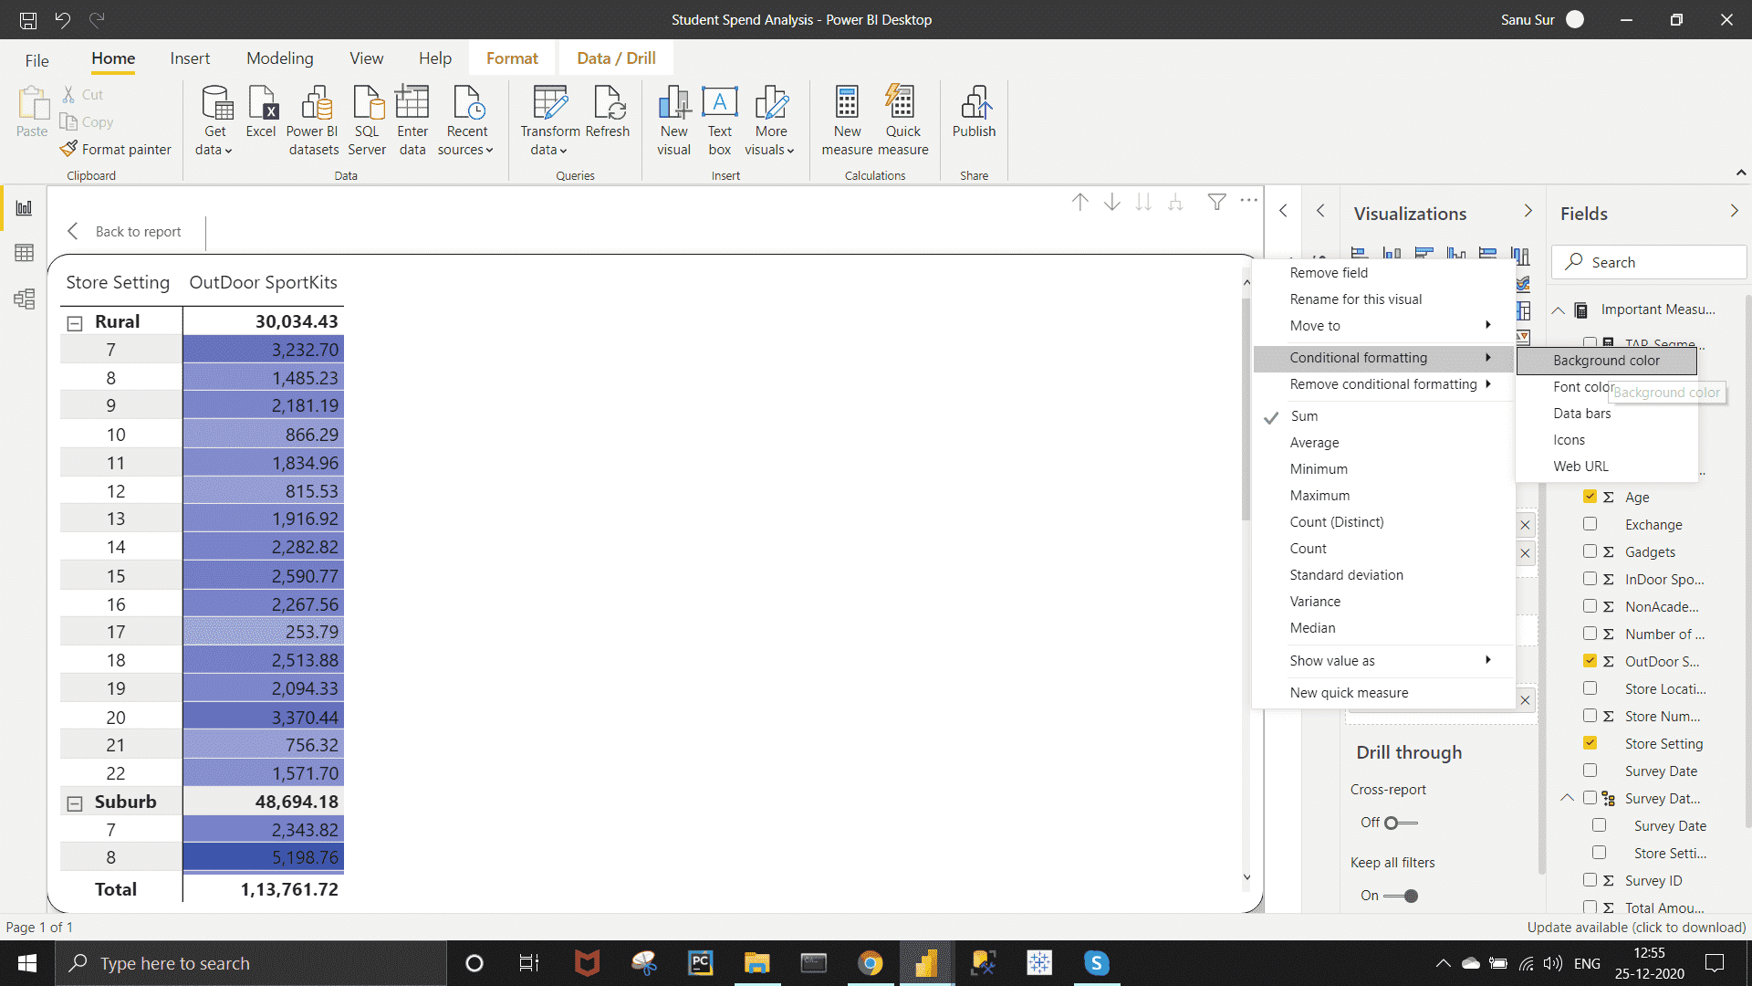

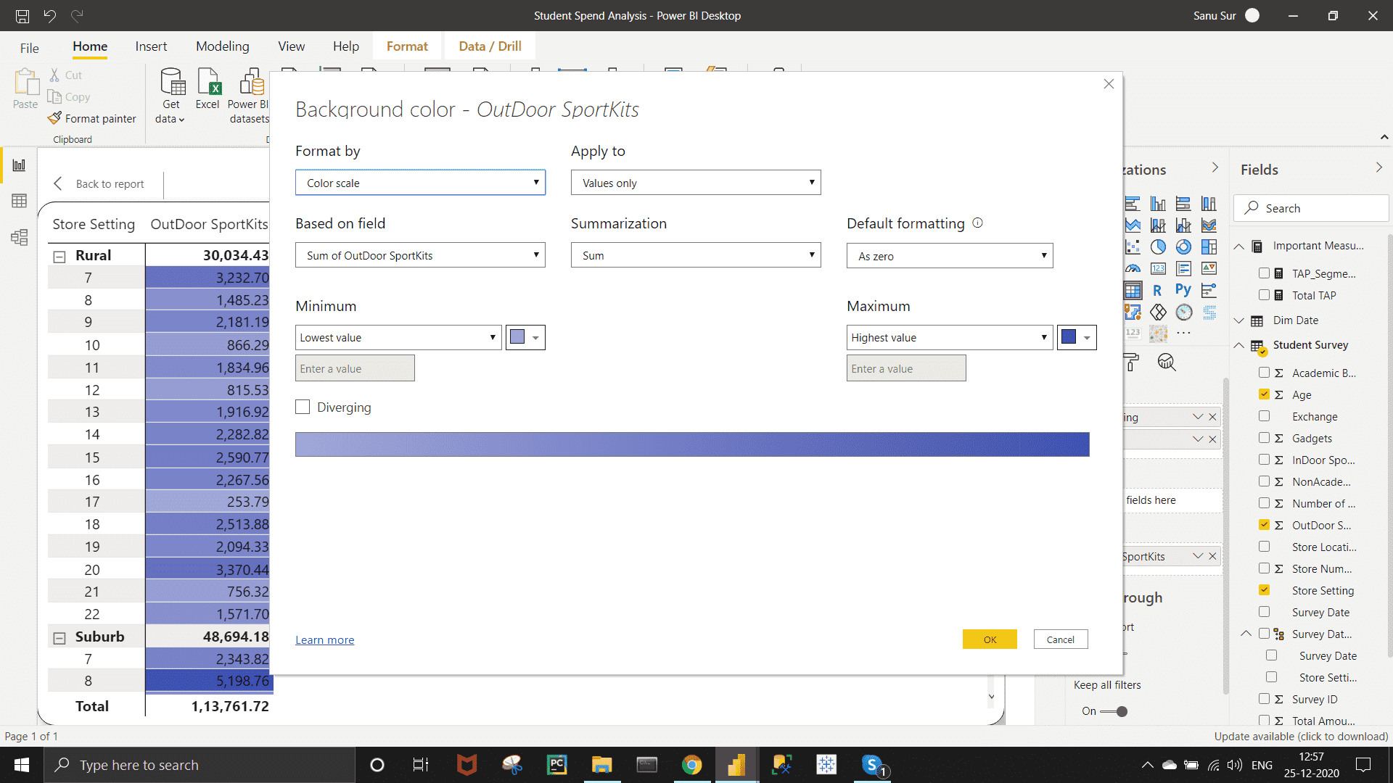

*Requirement 3* :-

*Funnel chart – Create a Funnel chart to show Total amount of purchase by ‘Store setting’. Show the data labels as Percentage of First.*

*Approach*:-

Click on Funnel chart from the visualization pen >>  Under field section, bring the "Store Setting" under Group section and "Total TAP" under Value section.

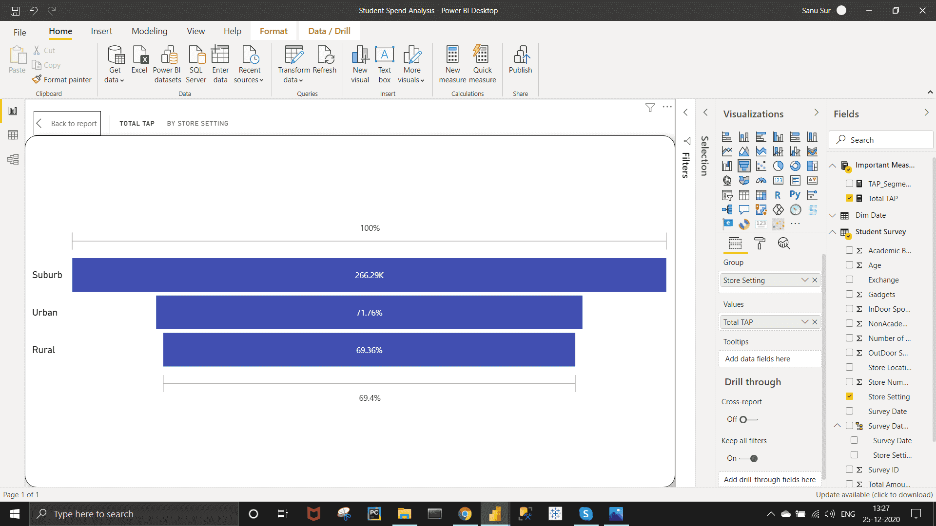

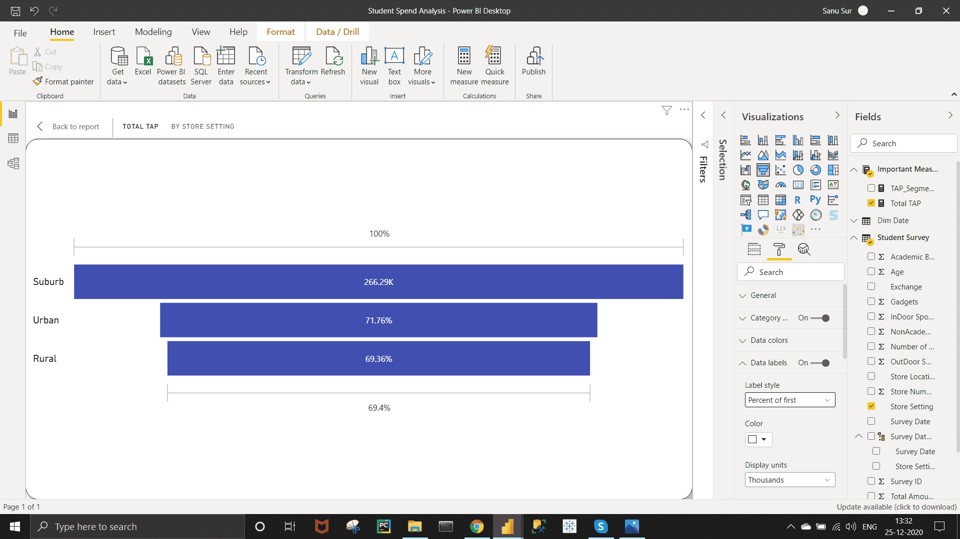

Now go to format section  >> Data labels >> Set Label Style as Percentage of first.

***Requirement 4***:-

*Pie chart – Show the total amount of purchase by different ‘Store location’ for Suburban ‘Store setting’ only.*

*Approach* :-

Create Pie chart using Store Location and Total TAP >> use visual level filter from filter pen  >> Select only the Suburban.

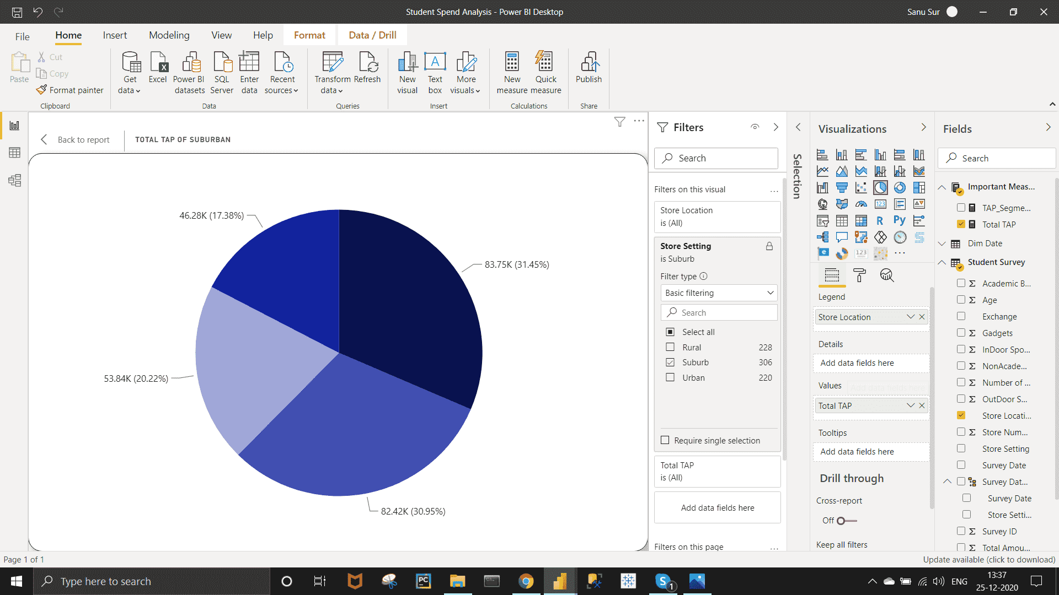

***Requirement 5 :-***

*Video games purchase and Outdoor sports spent across the different ages.*

*Approach :-*

Select Line Chart from visualization pen >> bring "OutDoor SprotsKit" and "VideoGame" under value section and "Age" under the Axis section..

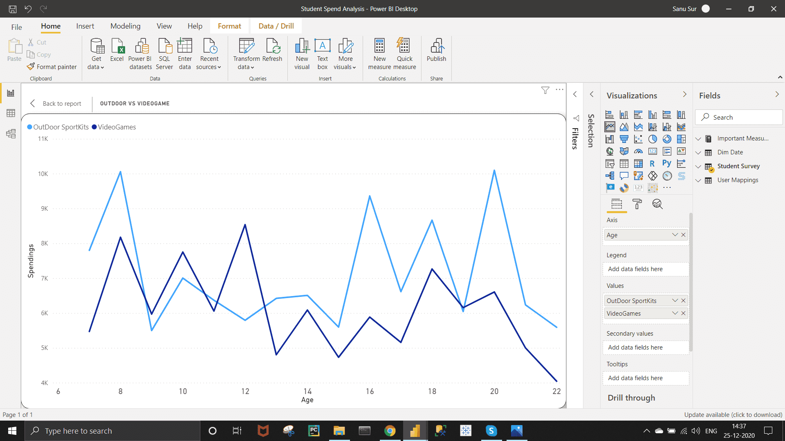

*Requirement  6* :-

Sand dance plot - Indoor sports and Video games spent across the different age groups.

Under Visualization pen click on three dots >>  Get more visuals >> Search for SandDance visual >> add it >> And Create a Scatter Chart in 3D view.

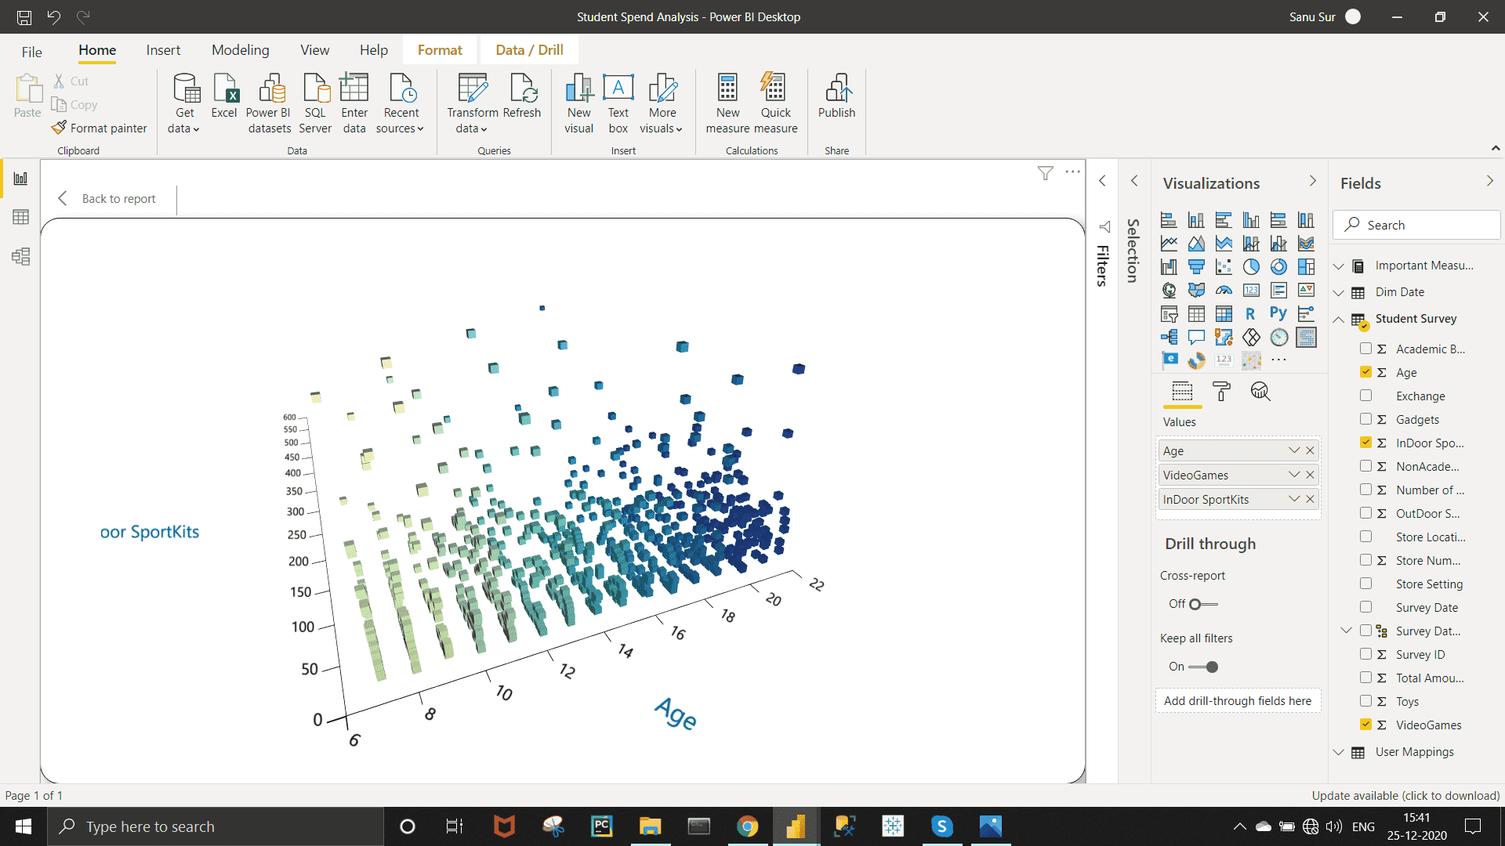

*Requirement 7 :-*

Restrict data access for the given users in User mapping table.

*Approach :-*

Go to Manage Roles >>>  go to create role >> Go to student Survey >> Write Store Settings = ""Rural" and OK.

To check the role , Go to View as >> From there , check the role. Then stop viewing.

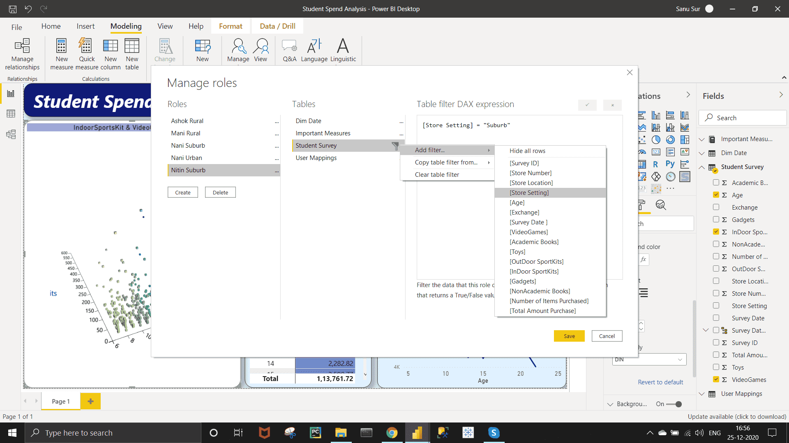

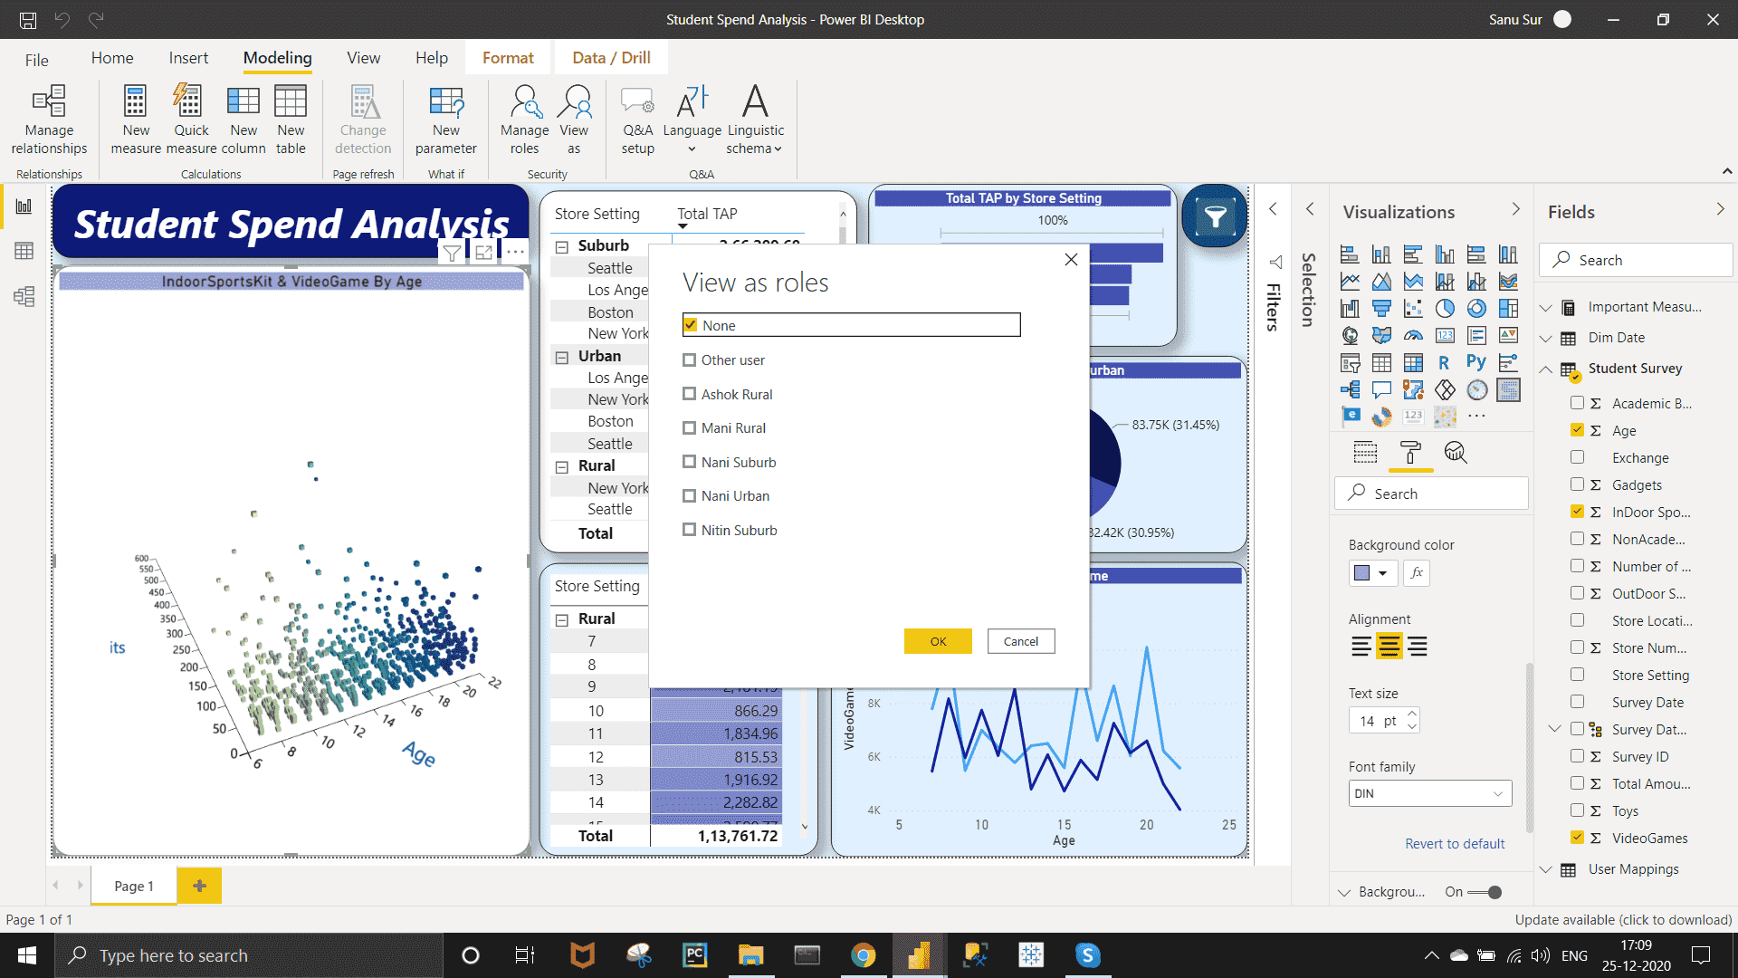

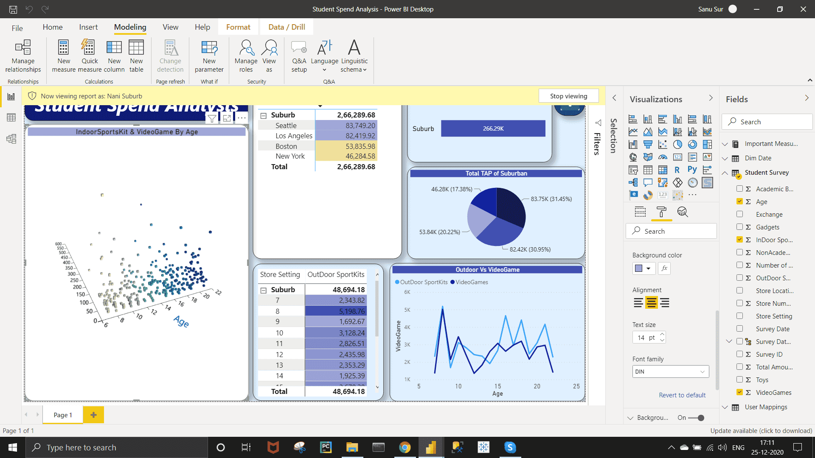

**Power BI Service :-**

*Requirement :-*

*Publish the report on Power BI cloud service and Design the Master Dashboard consisting of Funnel chart and scatter plots. Then create a schedule refresh for six times in every 4 hours for the Dashboard in a day.*

*Approach  :-*

To publish report,   
Save the report on the desktop level >> Click On Publish >> Select workbook on the new pop up  >> OK >> Open "Student Spend Analysis.pbix" in power BI. >> open your power bi account from your browser >> You can see the whole report view.

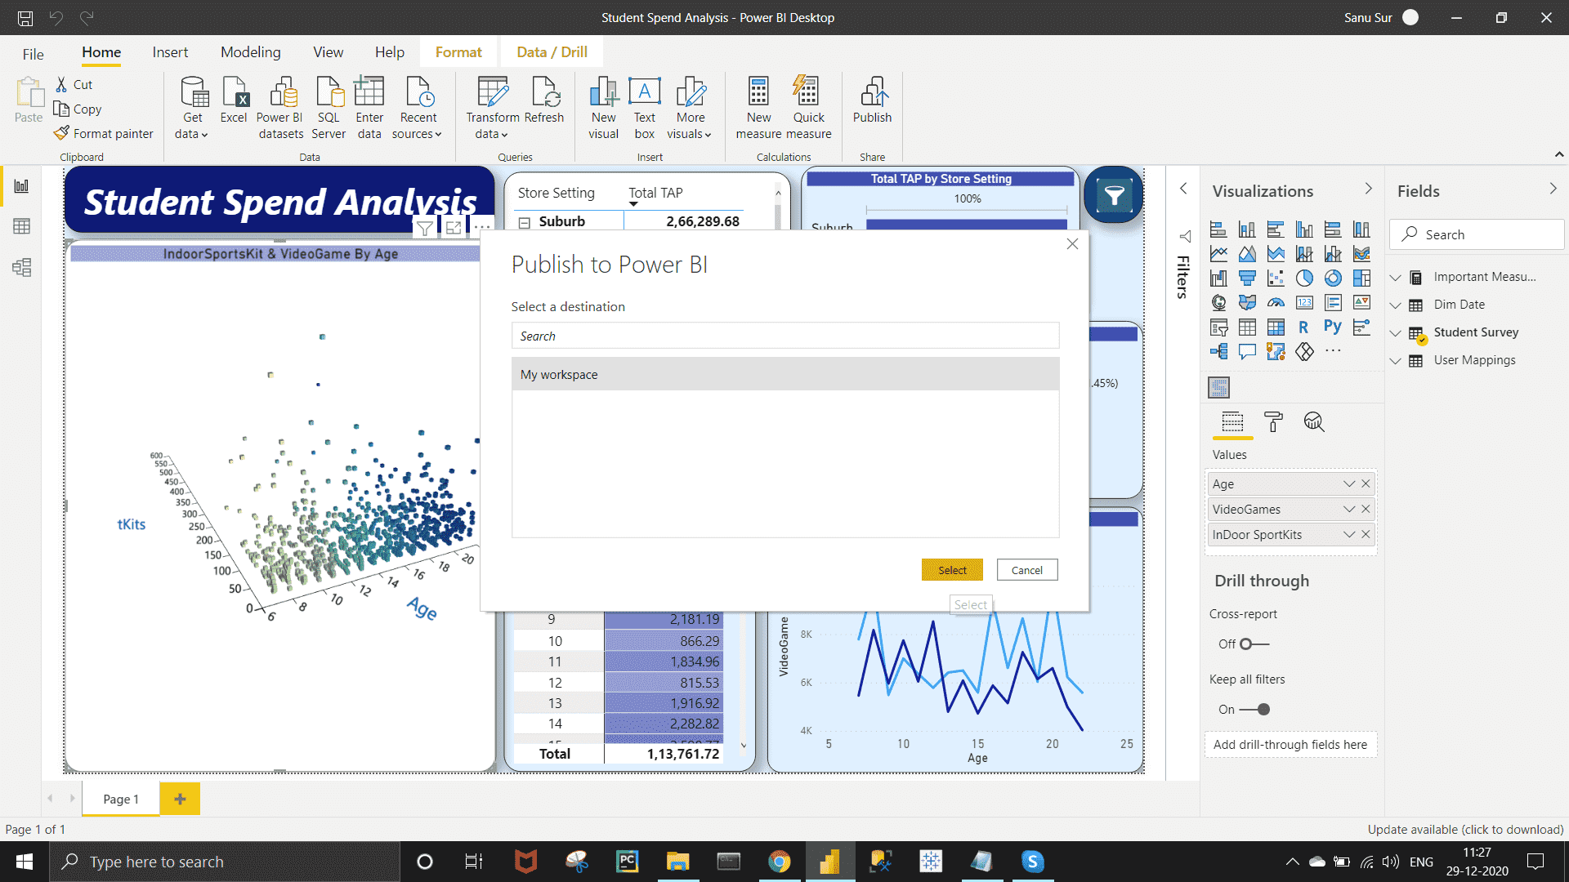

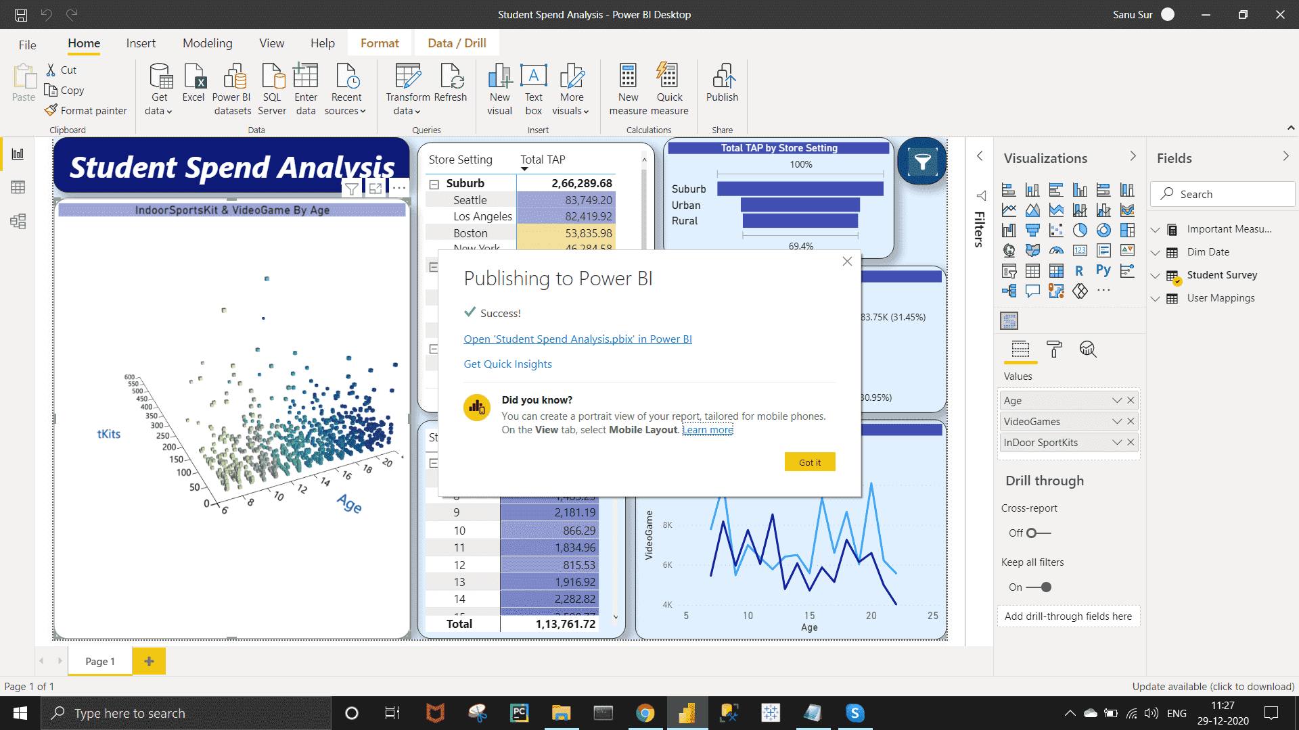

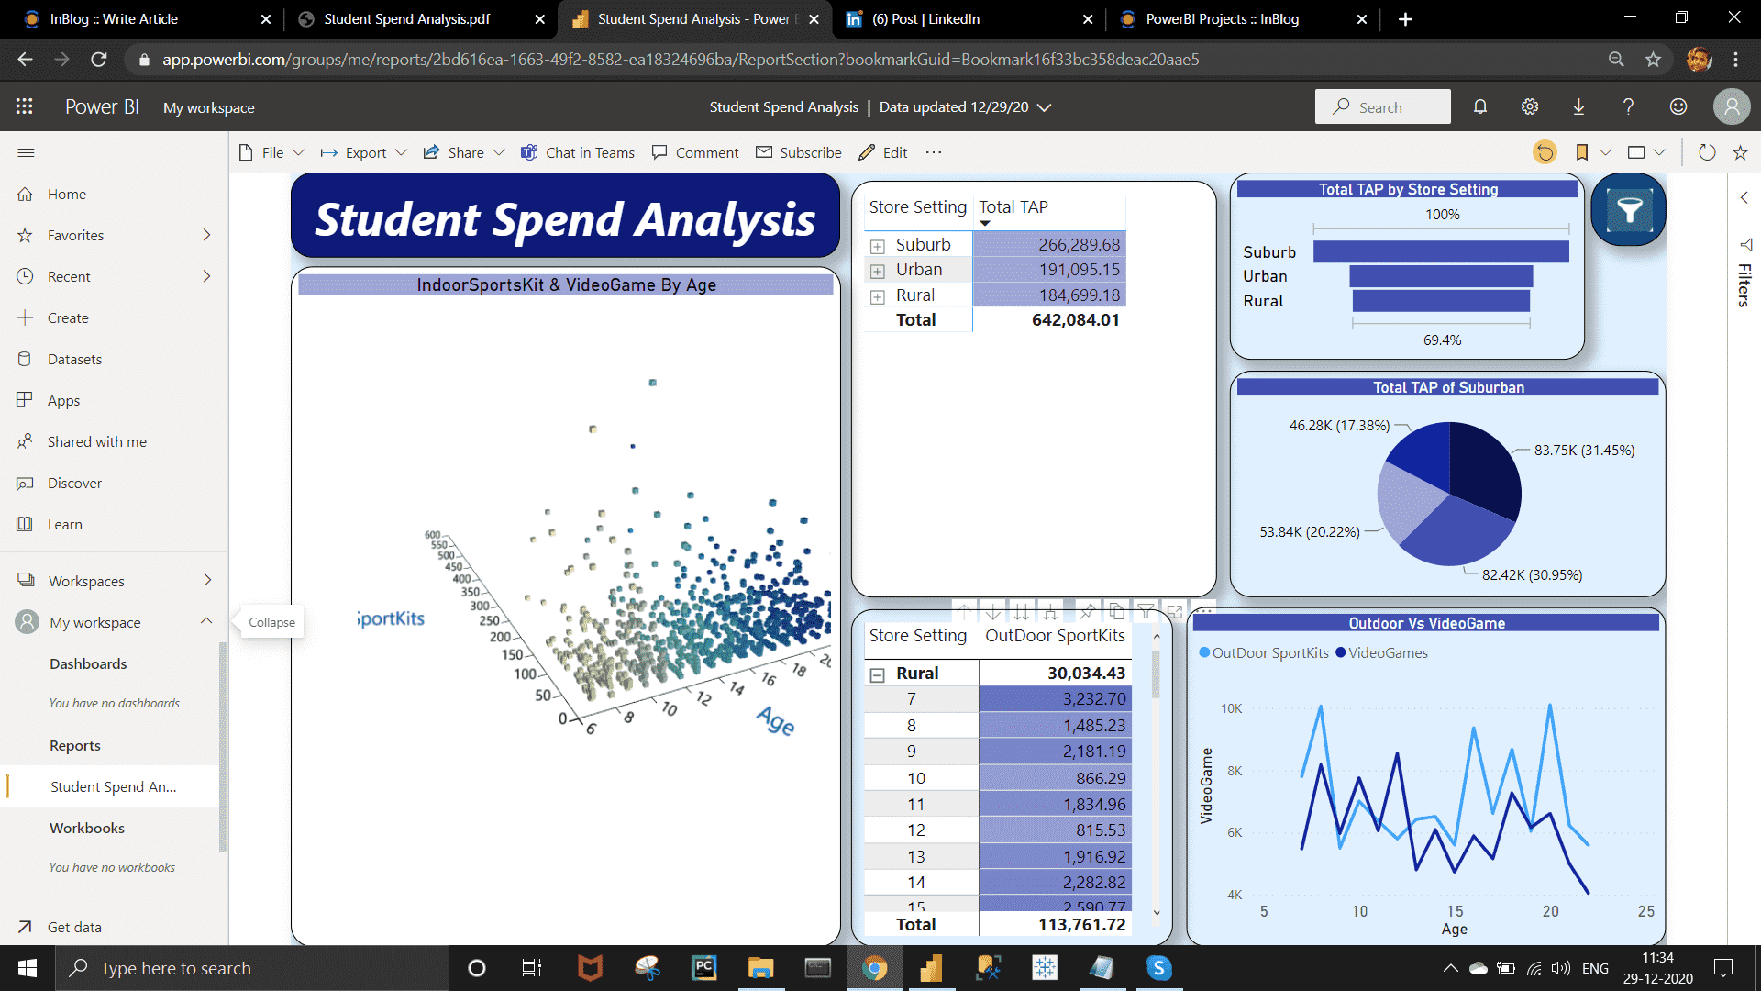

Now to create a Master dashboard, on the Visuals, click on Pin option >> Give a name to new dashboard >> Again Pin a new visual >> Pin on the existing dashboard .

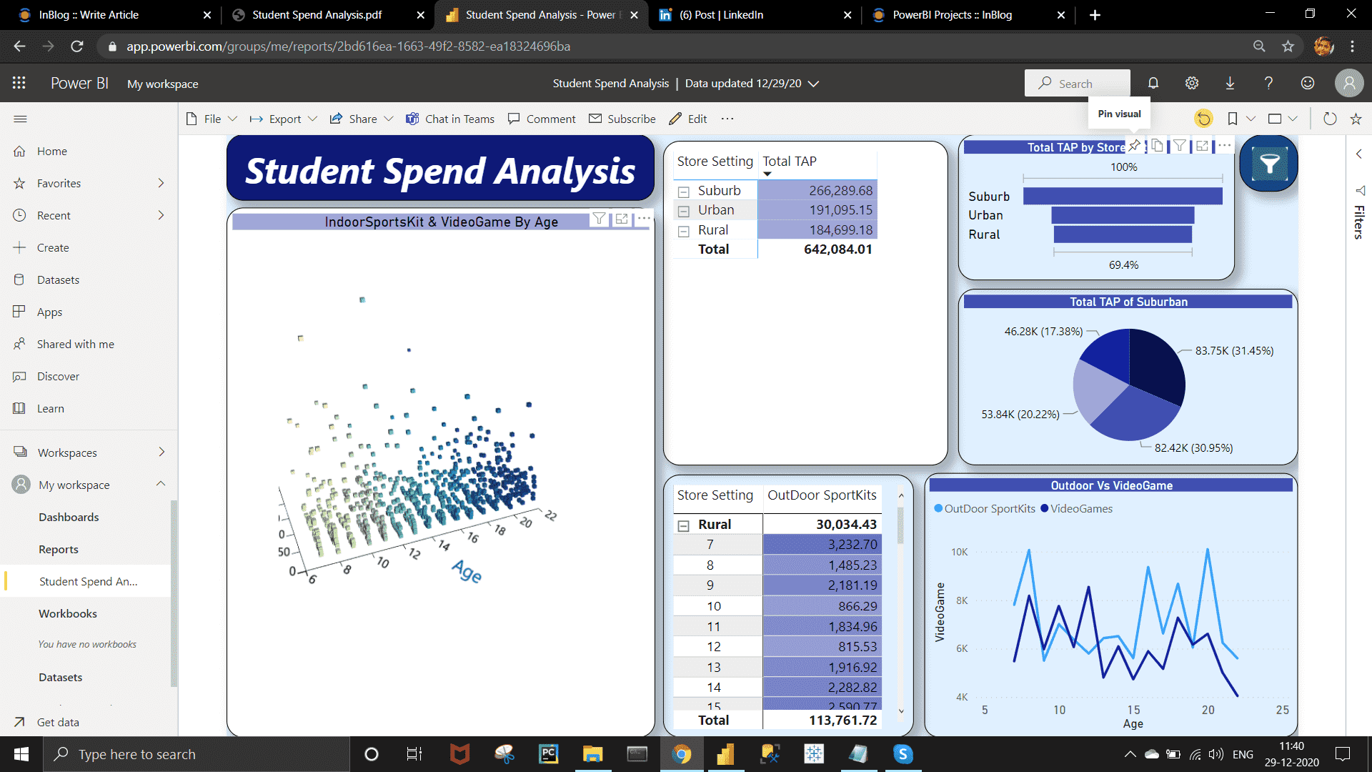

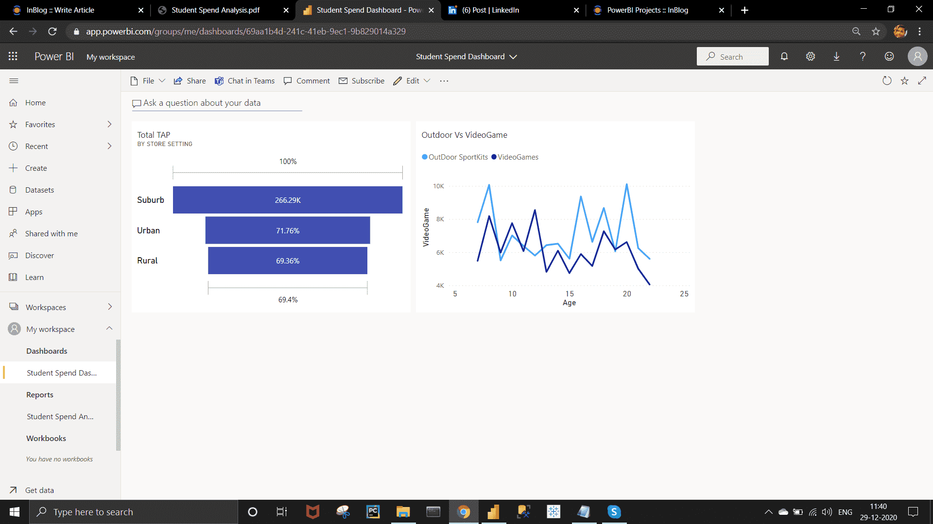

To Schedule Refresh :-  
Go to Datasets Under My workspace >> Click on three dot on your dataset >> Click on Schedule refresh >> On the new window install the gateway .

Under the Schedule refresh ,  DATA UP TO DATE do turn on. >> keep refreshment frequency in daily >> Set the refreshment time as require.

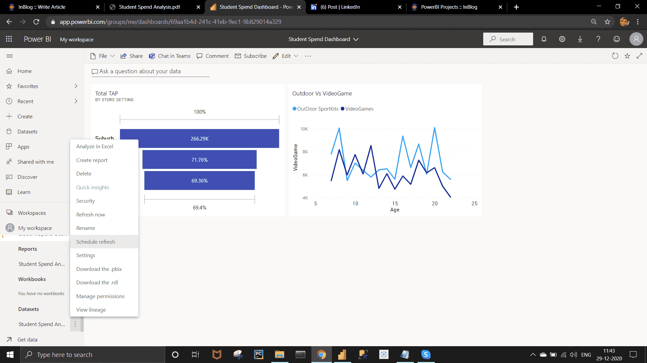

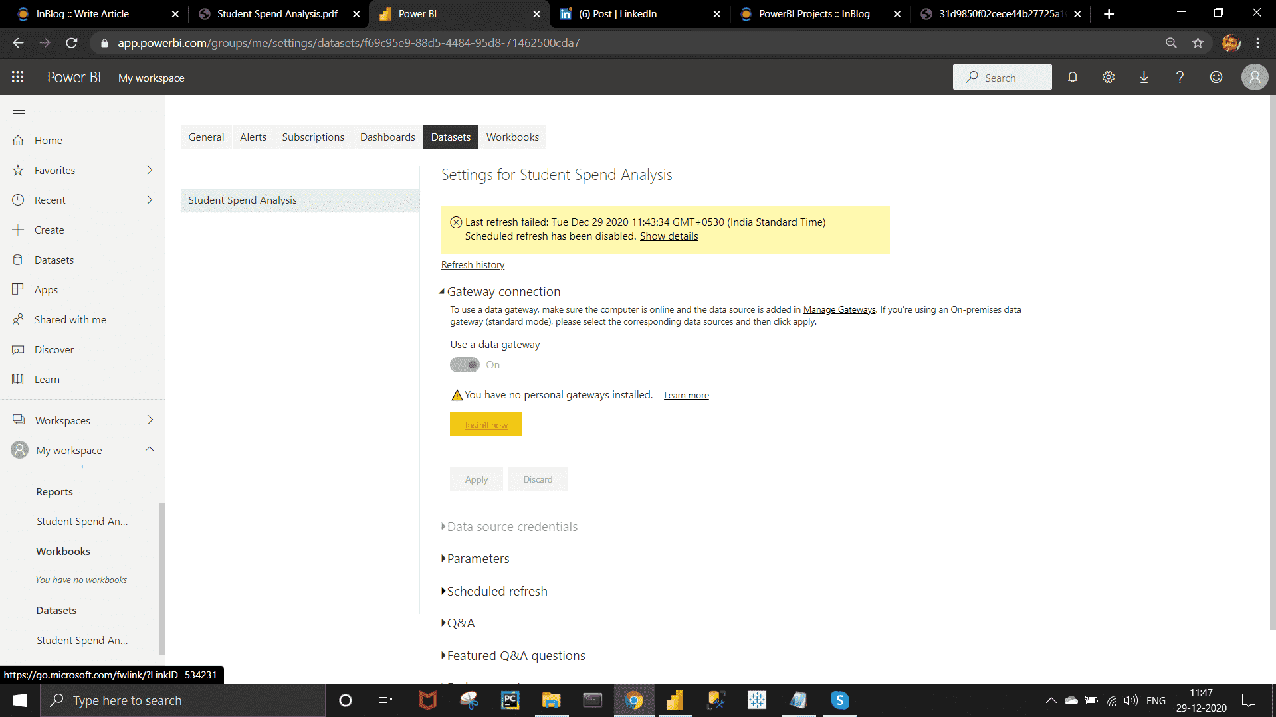

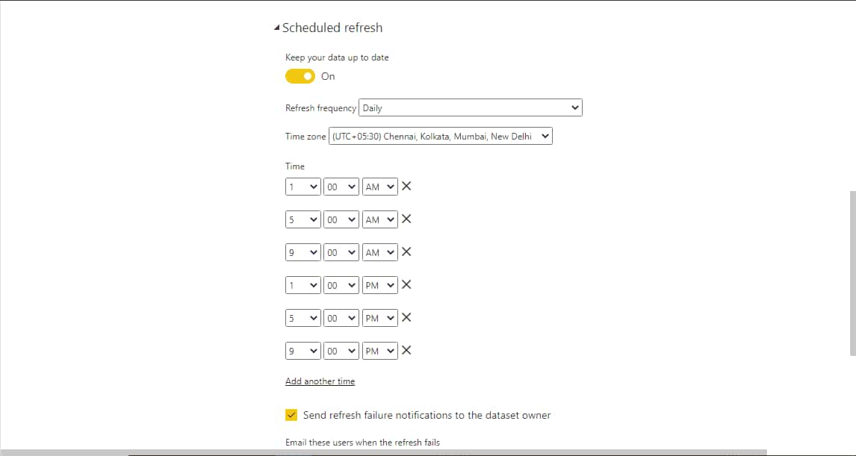

Requirement :-

Use Q&A feature of Power BI –

a) To show average age of students.

b) Donut chart for total amount of purchases by ‘Store location’.

Approach :-

In the Master Dashboard , there have a "Ask a question about your data " option >> go there and write your query to get result. >> You can Pin the visual in your existing dashboard.

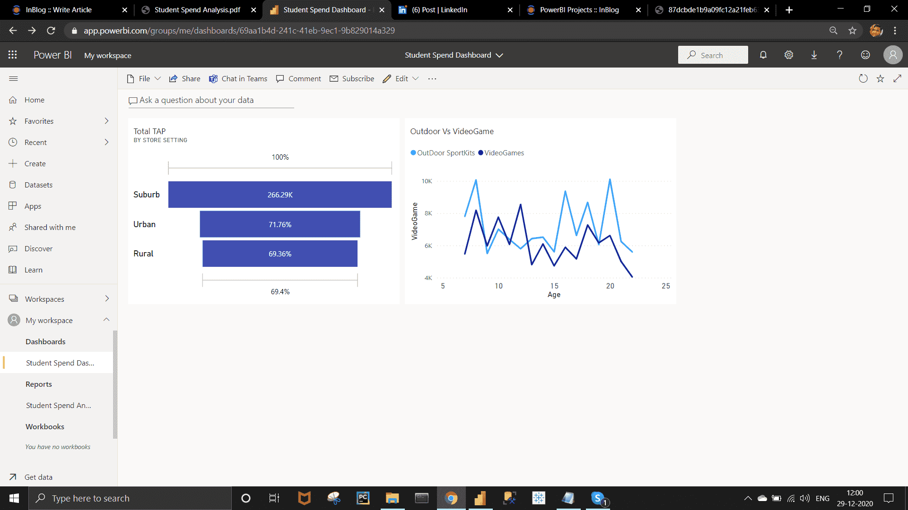

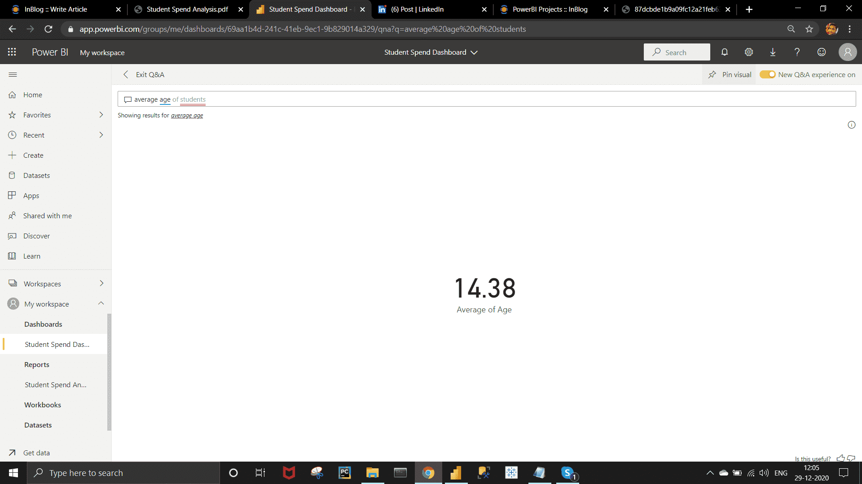

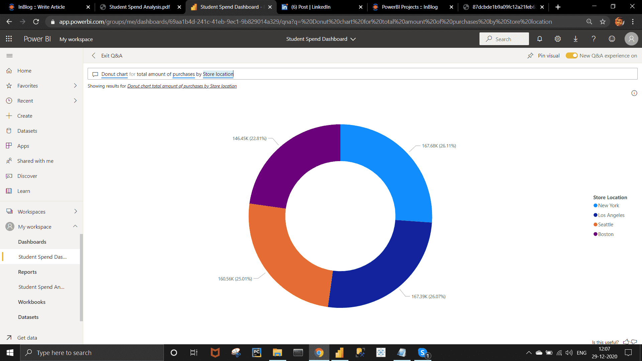

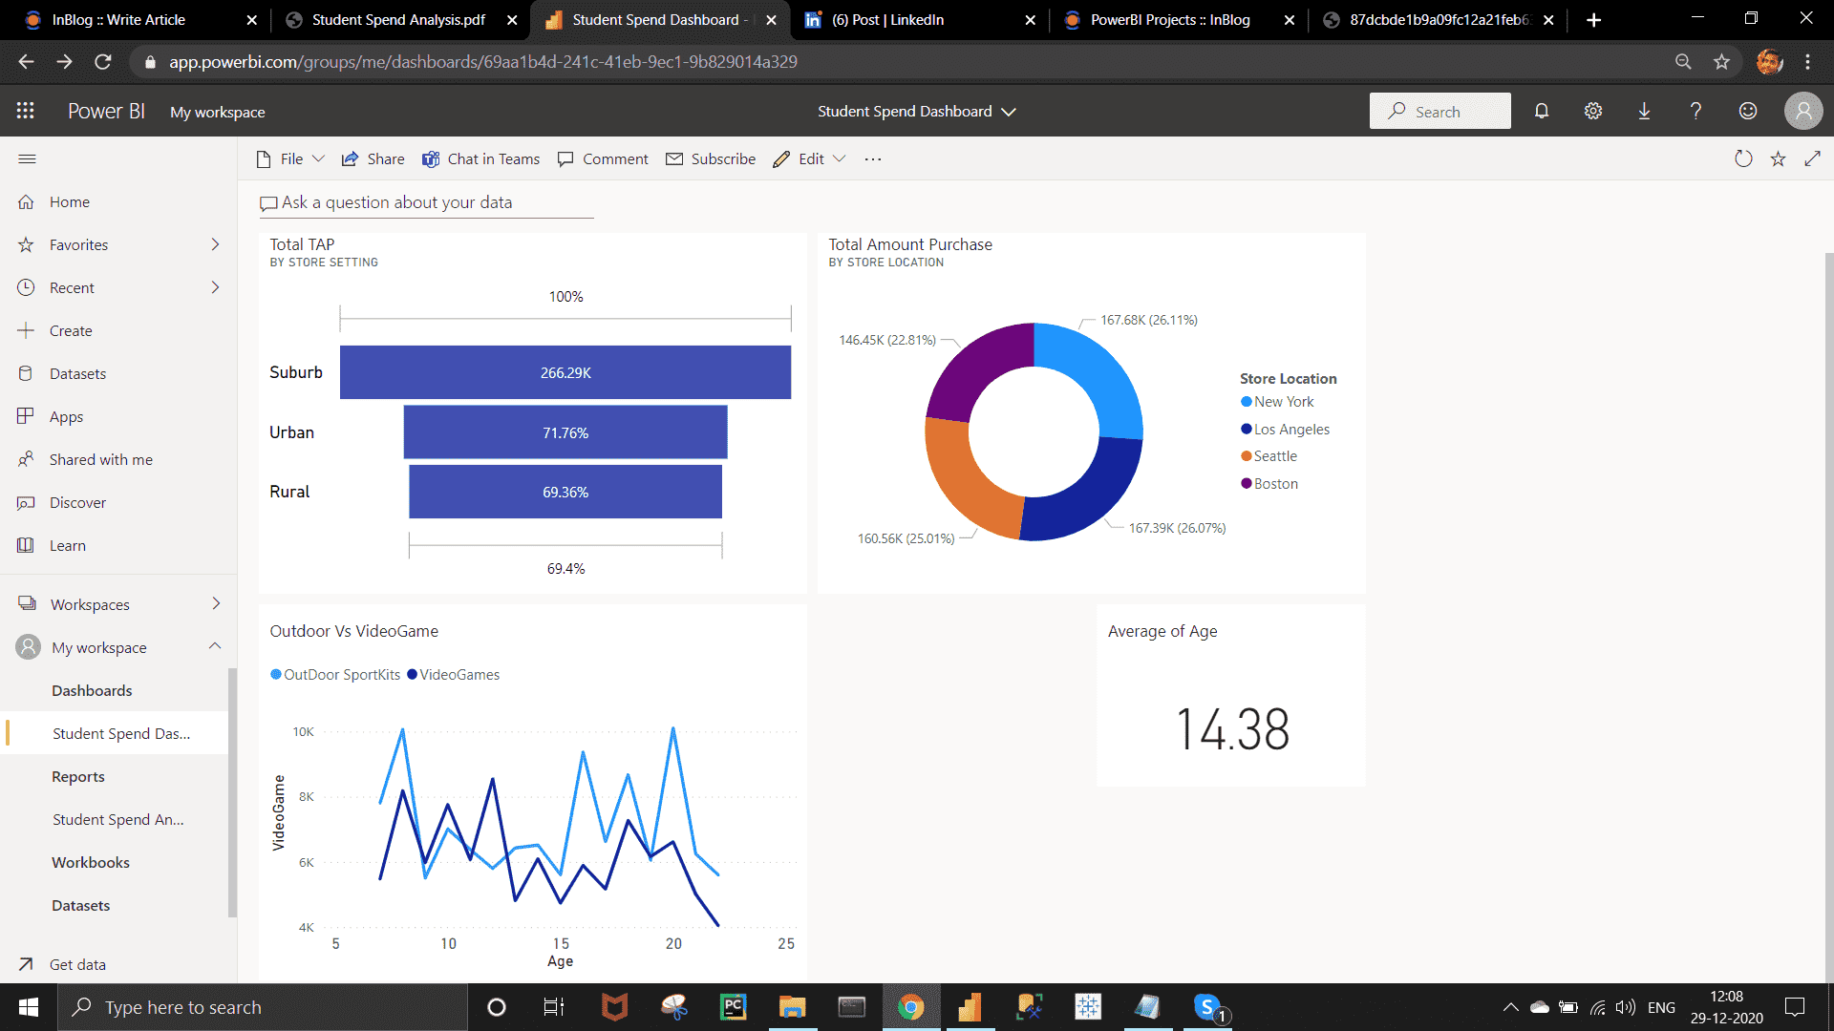

Master Dashboard

Whole Report View :-

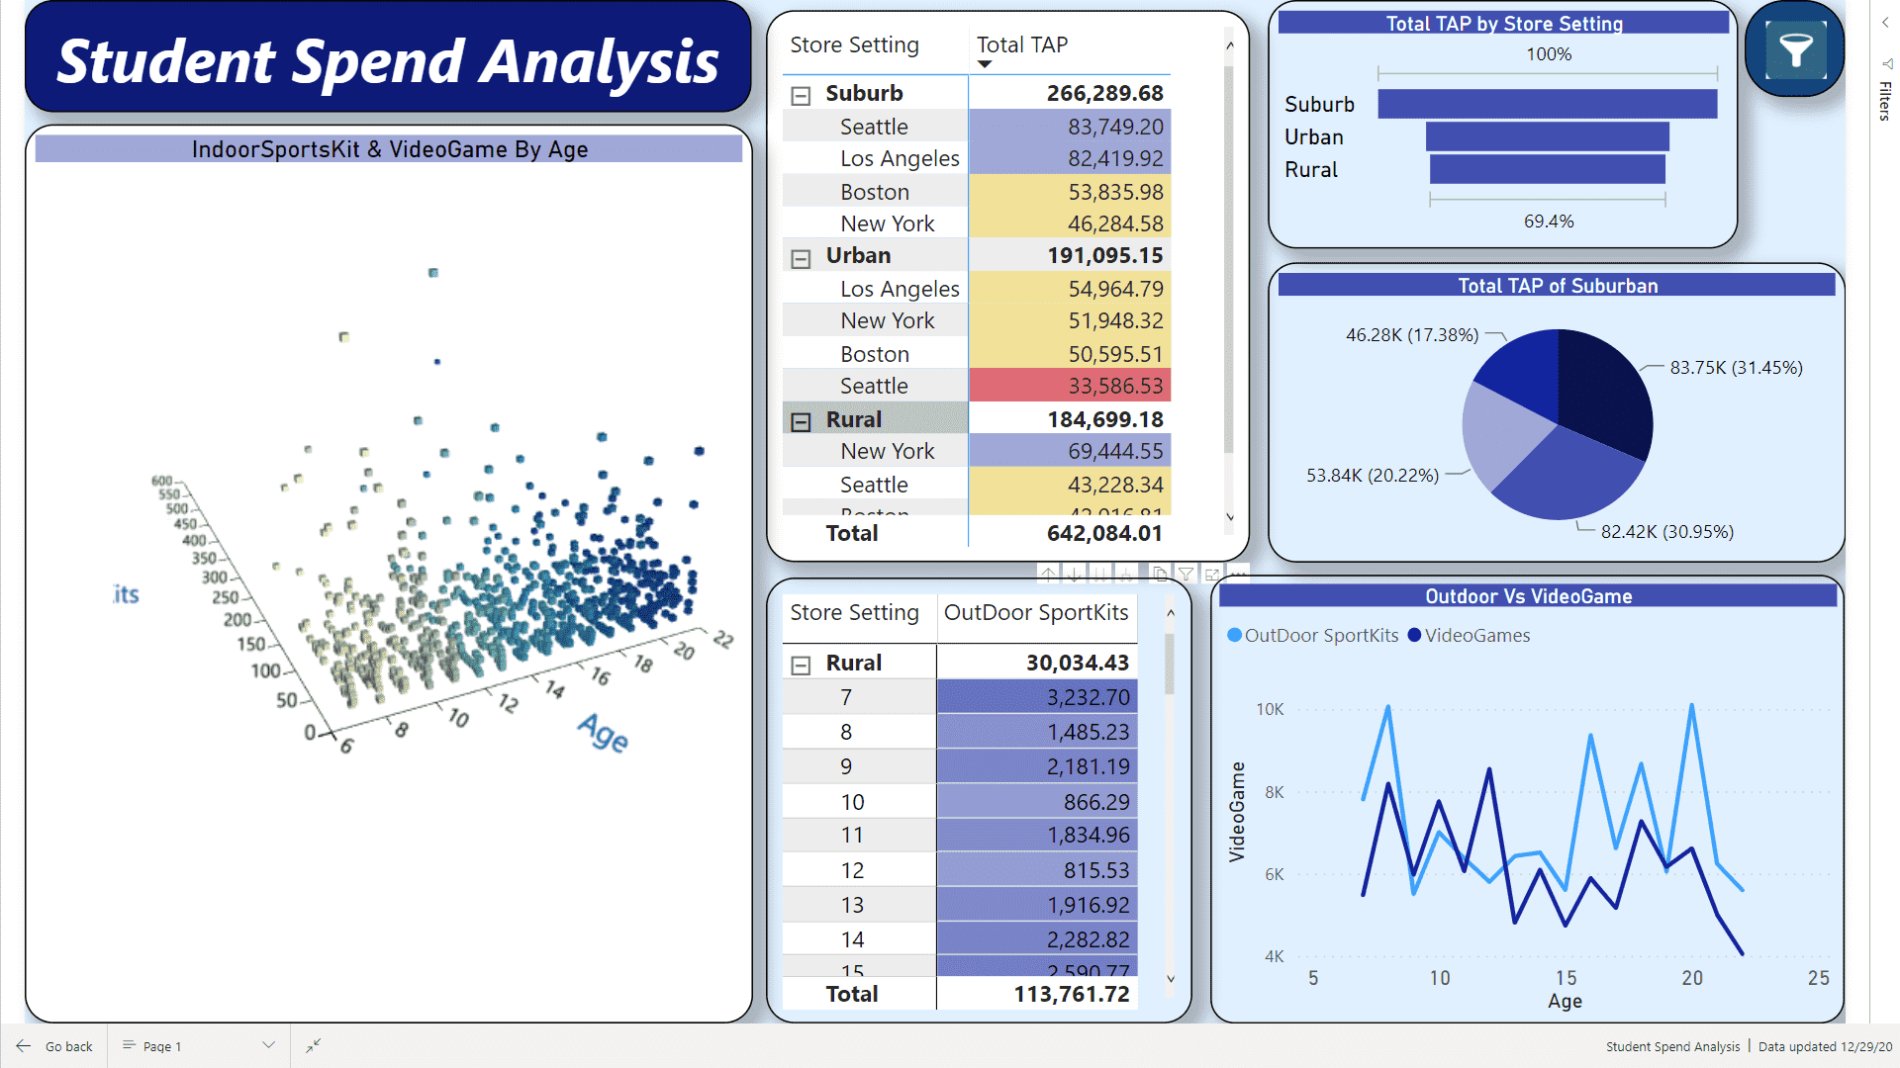

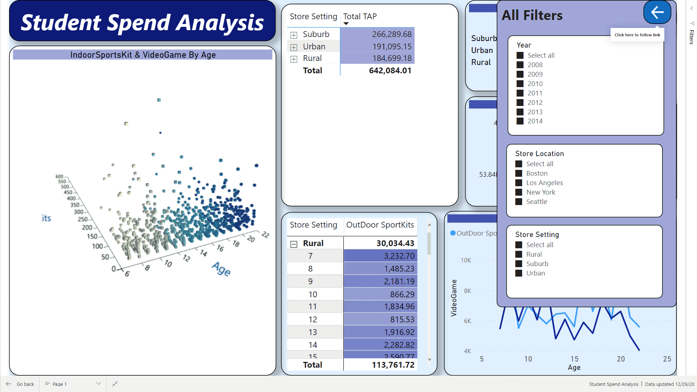

***Some Useful Insights :-***

• From the funnel chart we can see the suburban have highest Total Amount of Purchase. Urban is 71.76 % of Suburban.

• As Age increases, Spent on the Video Game purchases decreases more quickly than Outdoor Game purchases .

• After 13 , Students start spending more on outdoor game than Video game.